**MongoDB Task**

**Design database for Zen class programme**

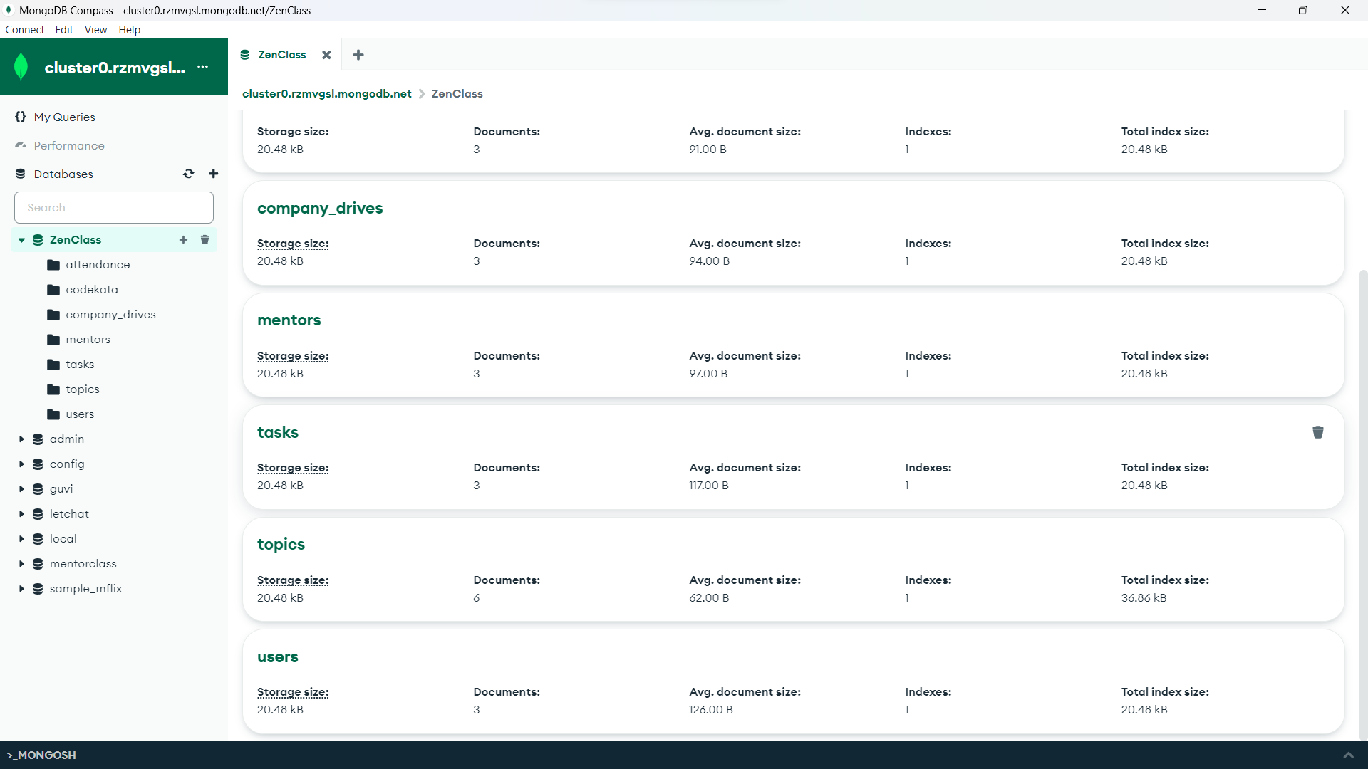

**Users, codekata, attendance, topics, tasks, company_drives, mentor** collections are created

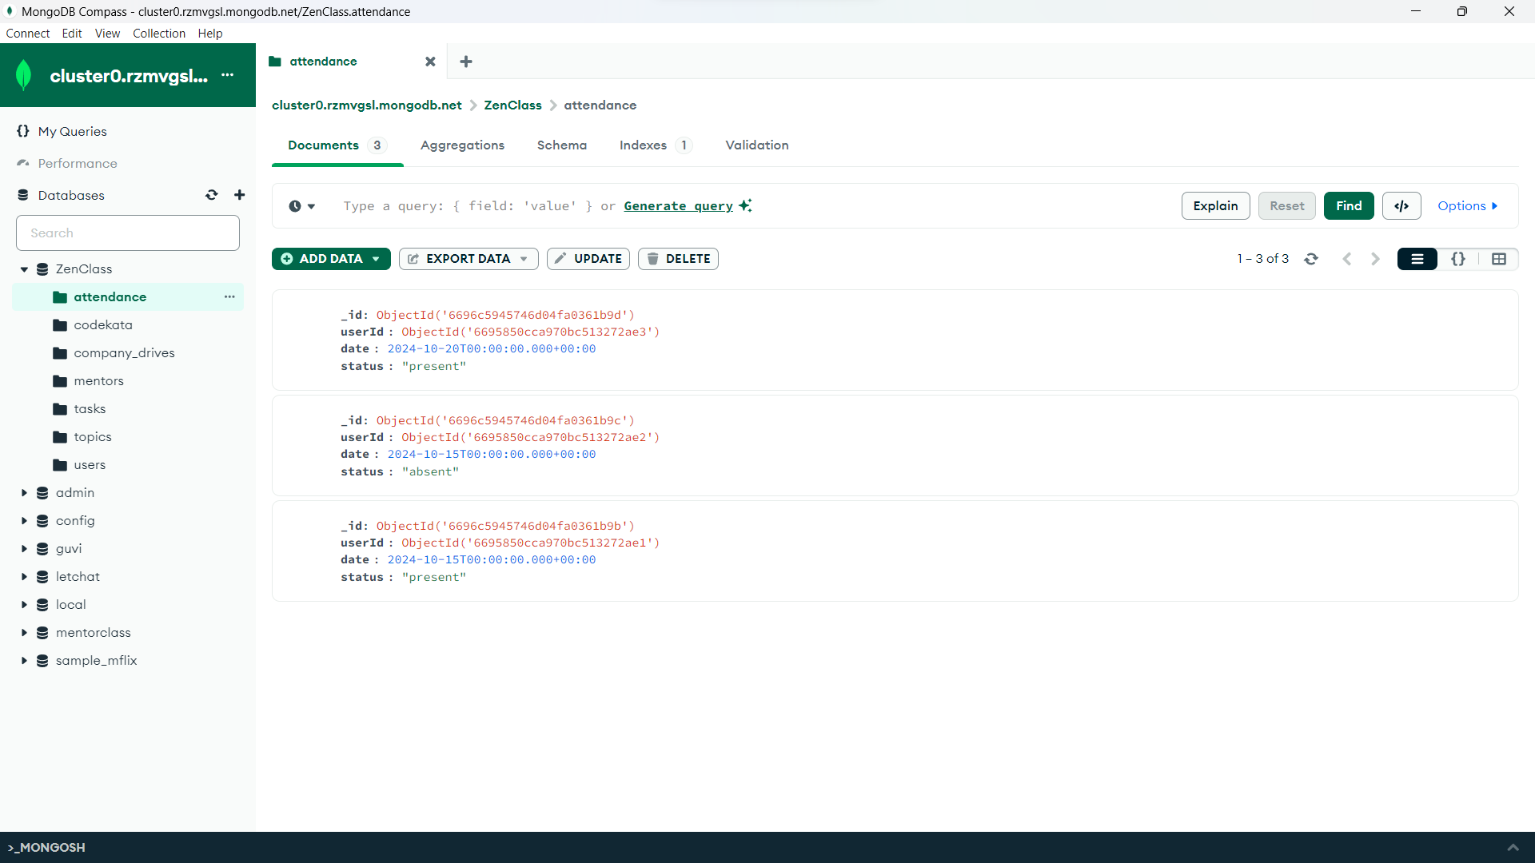

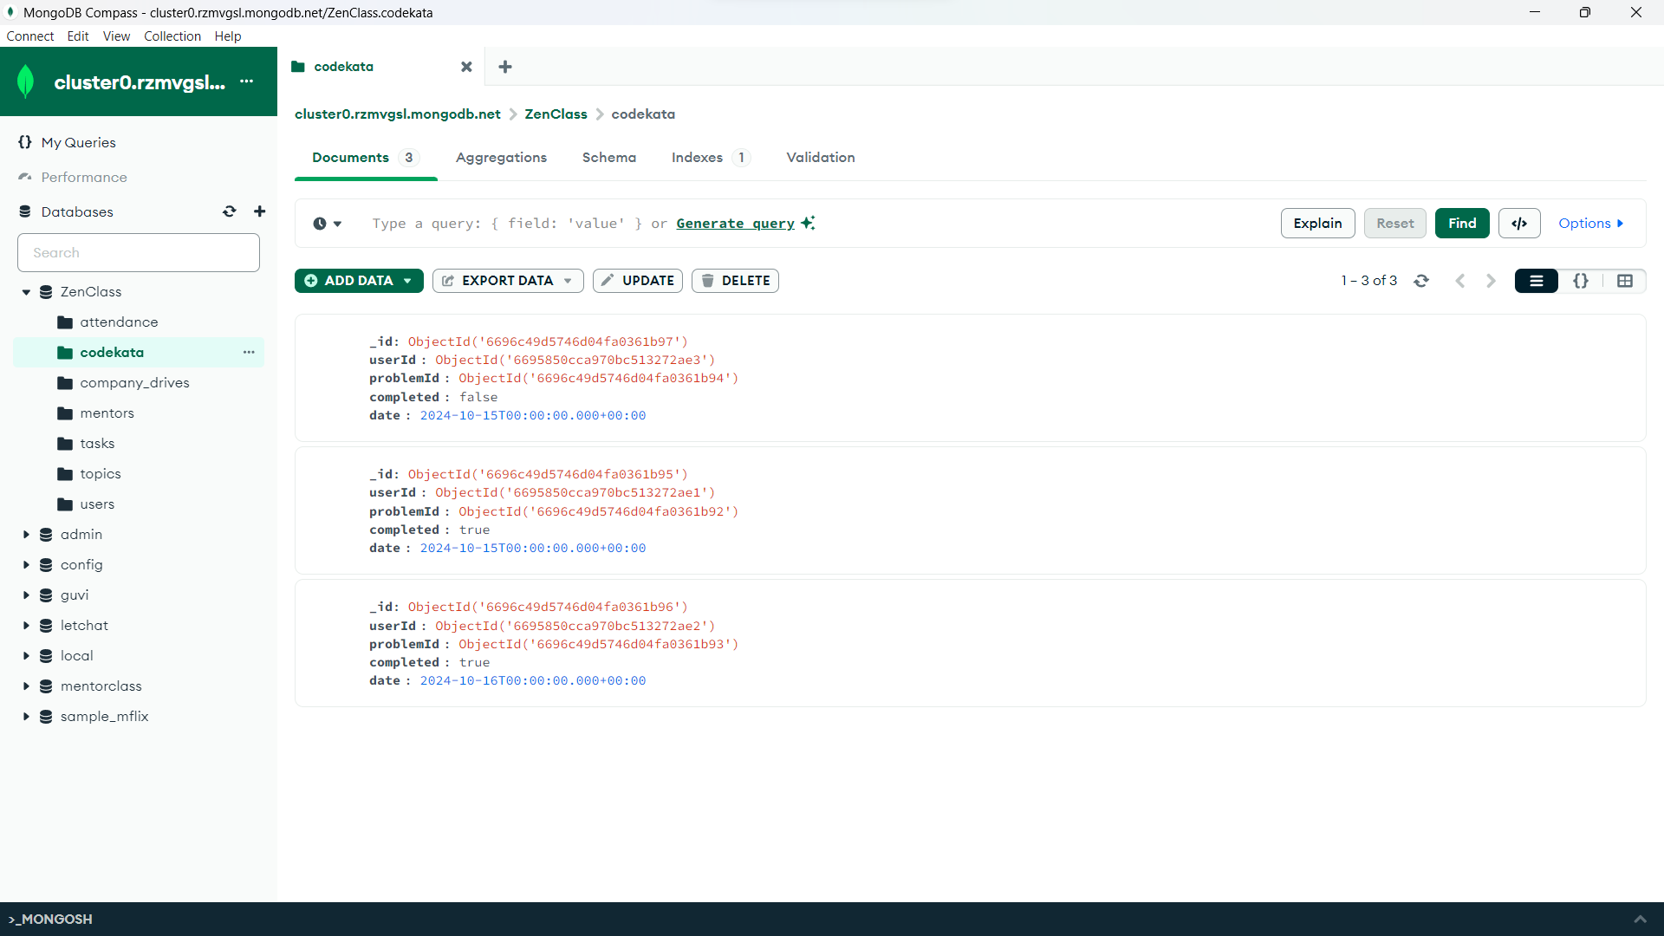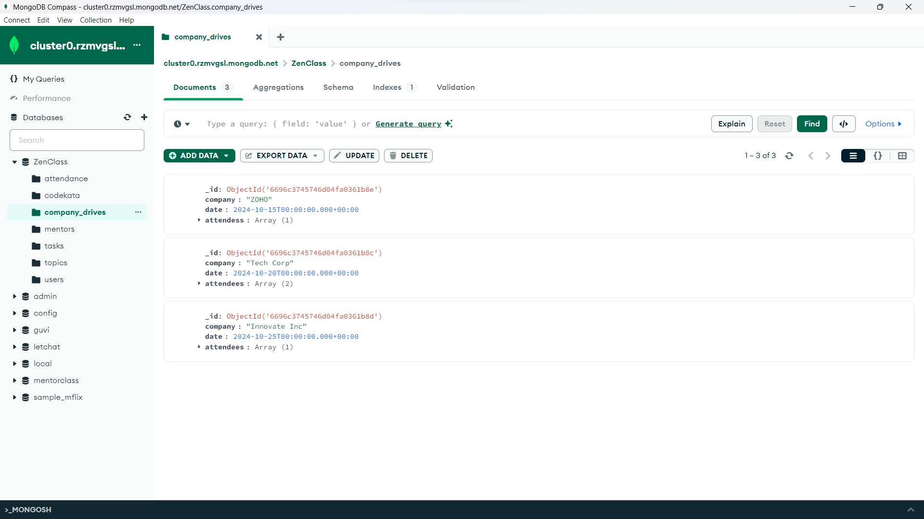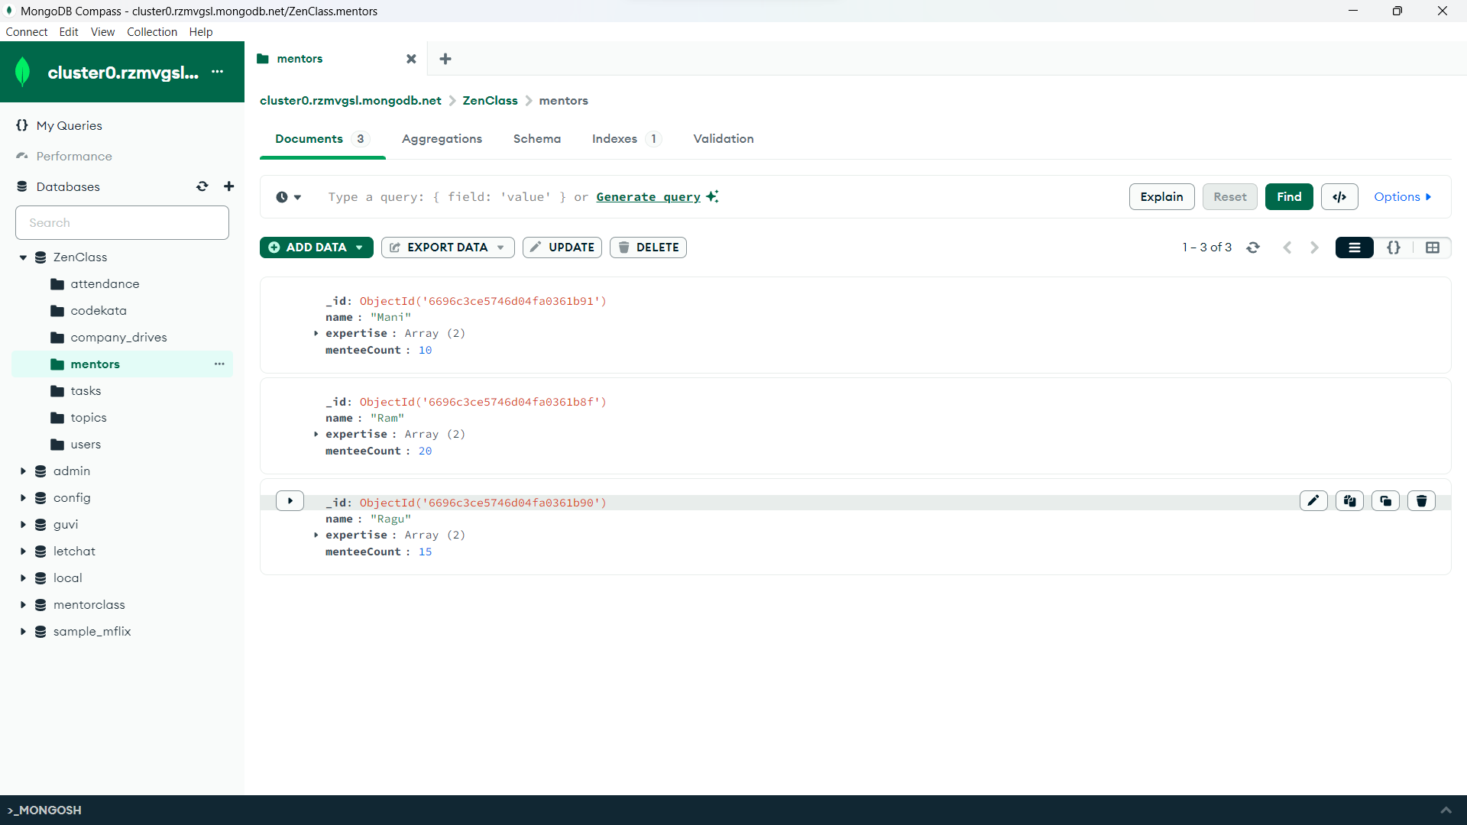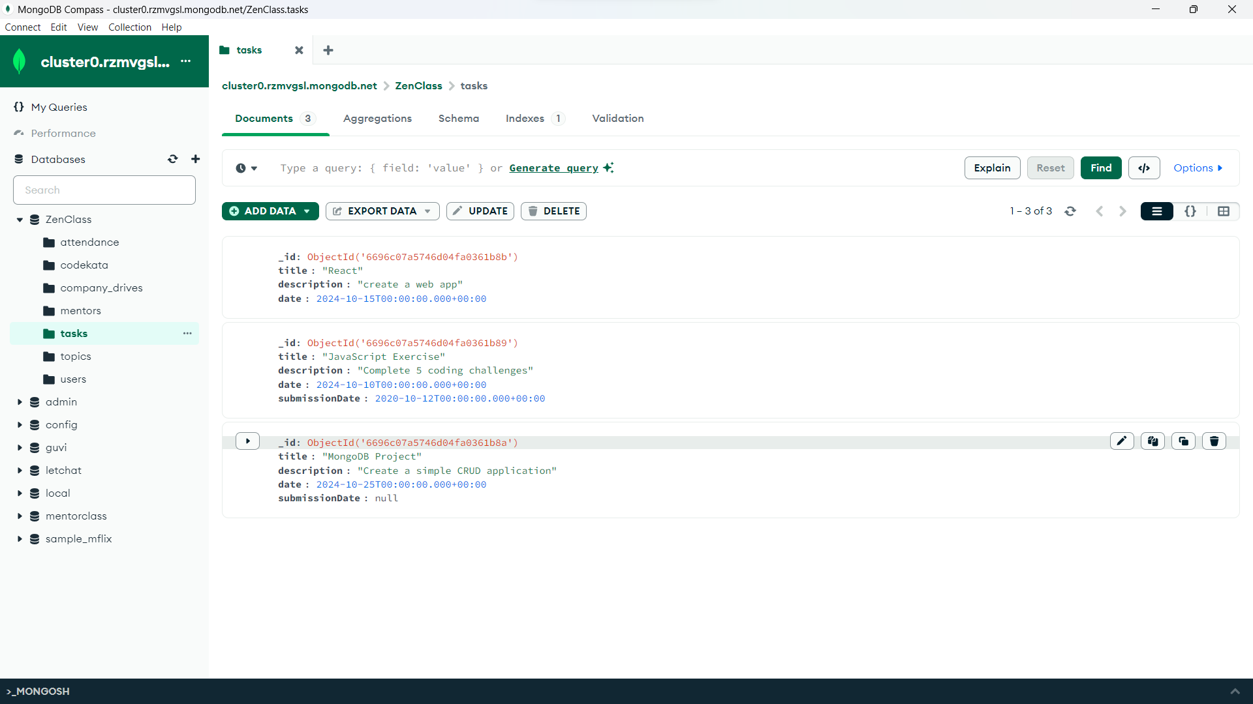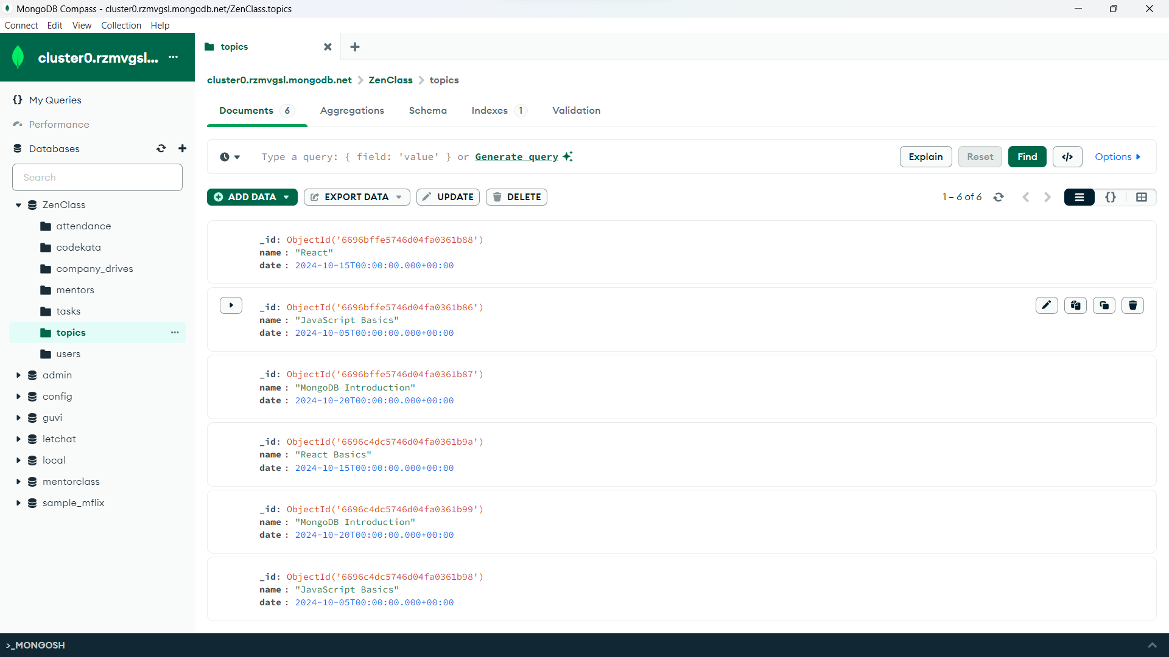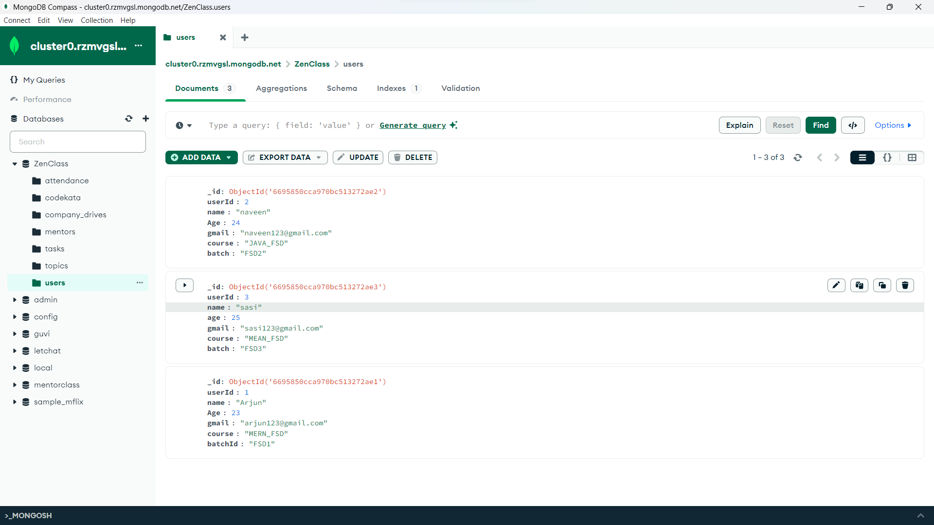

**1.Find all the topics and tasks which are thought in the month of October**

db.topics.find({ date: { $gte: ISODate("2024-10-01"), $lt: ISODate("2024-11-01") } })

db.tasks.find({ date: { $gte: ISODate("2024-10-01"), $lt: ISODate("2024-11-01") } })

**2.** **Find all the company drives which appeared between 15 oct-2024 and 31-oct-2024**

db.company_drives.find({

date: {

$gte: ISODate("2024-10-15"),

$lte: ISODate("2024-10-31")

}

})

**3. Find all the company drives and students who are appeared for the placement.**

db.company_drives.aggregate([

{

$lookup: {

from: "users",

localField: "attendees",

foreignField: "_id",

as: "students"

}

},

{

$project: {

company: 1,

date: 1,

"students.name": 1,

"students.email": 1

}

}

])

**4. Find the number of problems solved by the user in codekata**

db.codekata.aggregate([

{

$group: {

_id: "$userId",

problemsSolved: { $sum: 1 }

}

},

{

$lookup: {

from: "users",

localField: "_id",

foreignField: "_id",

as: "userInfo"

}

},

{

$project: {

"userInfo.name": 1,

problemsSolved: 1

}

}

])

**5. Find all the mentors with who has the mentee's count more than 15**

db.mentors.find({ menteeCount: { $gt: 15 } })

**6.** **Find the number of users who are absent and task is not submitted  between 15 oct-2024 and 31-oct-2024**

db.users.aggregate([

{

$lookup: {

from: "attendance",

localField: "_id",

foreignField: "userId",

as: "attendanceInfo"

}

},

{

$lookup: {

from: "tasks",

localField: "_id",

foreignField: "userId",

as: "taskInfo"

}

},

{

$match: {

$and: [

{ "attendanceInfo.date": { $gte: ISODate("2024-10-15"), $lte: ISODate("2024-10-31") } },

{ "attendanceInfo.status": "absent" },

{

$or: [

{ "taskInfo": { $size: 0 } },

{ "taskInfo.submissionDate": null }

]

}

]

}

},

{

$count: "absentAndNotSubmitted"

}

])